# Chapter Seven: Demonstration

## 7.1 Activity Flow Diagram

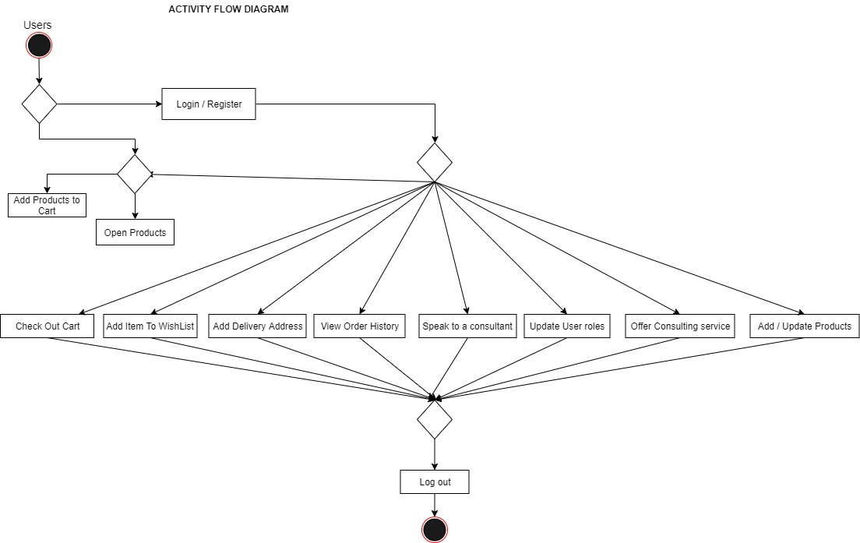

## 7.2 Activity Flow Screen

### 7.2.1 Home Screen

This is the web app home screen, this window provides users the ability to navigate through all the medicines available in the pharmaceutical stores, it also gives the user’s ability to filter through the products either by category or price range. Users can also add items to cart or wish list.

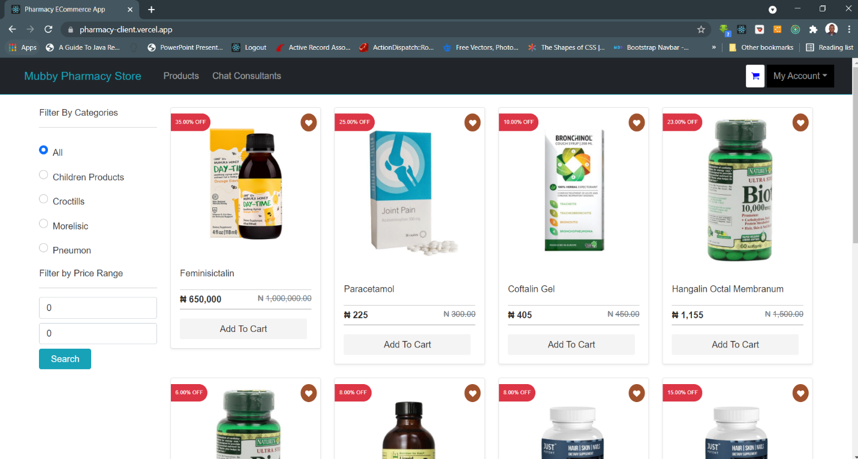

### 7.2.2 Login / Register Screen

This screen provides two functionalities, the login and the register screen. The login allow user to login into the system by providing their email address and password while the register form can be use by users to register their information for the first time by providing their name, phone, email and password.

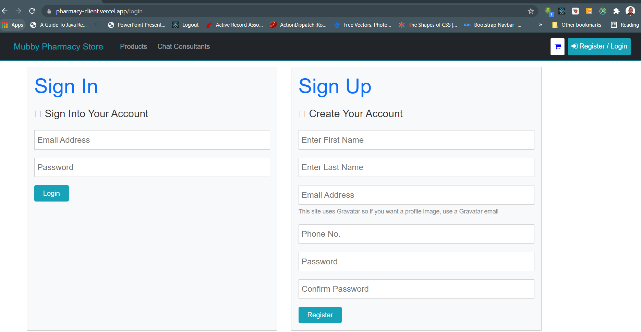

### 7.2.3 Cart Review Window

This screen provides the users with the complete review of items in their cart. With this screen the users will be able to add or remove item from their cart before the final check out.

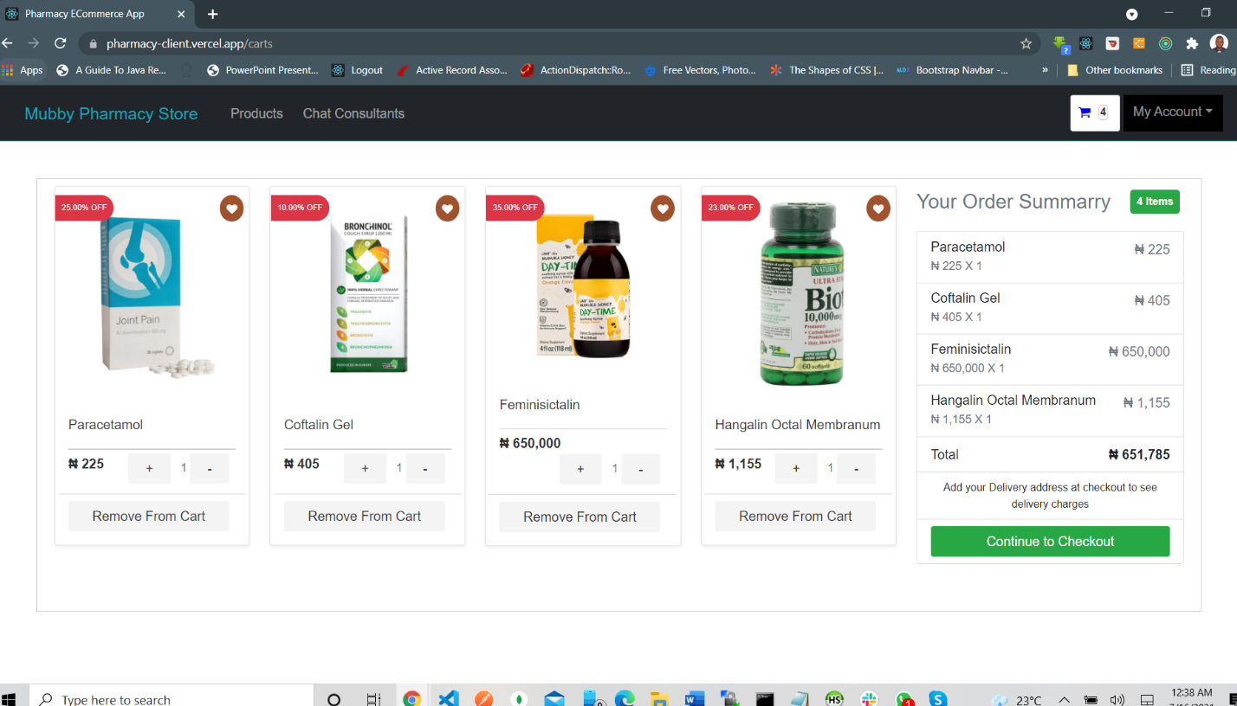

### 7.2.4 Check Out Screen

This screen provide user with a complete summary of the cart items and the grand total of every item in the cart. In this screen users will be able to select their payment method and add or change their delivery locations. If pay now is selected the screen will present a form for the user to input a credit card information for the check out. User can also modify the items in their cart from this list (by either removing the item from cart or adding it to the Wishlist).

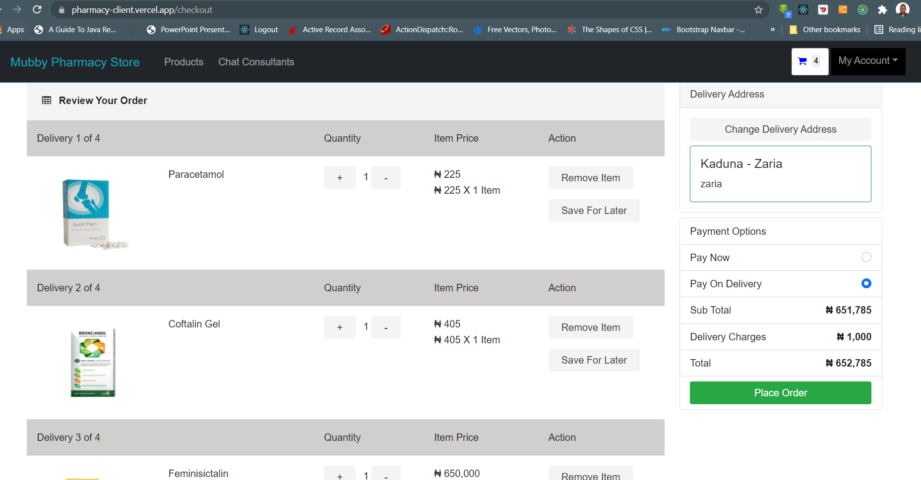

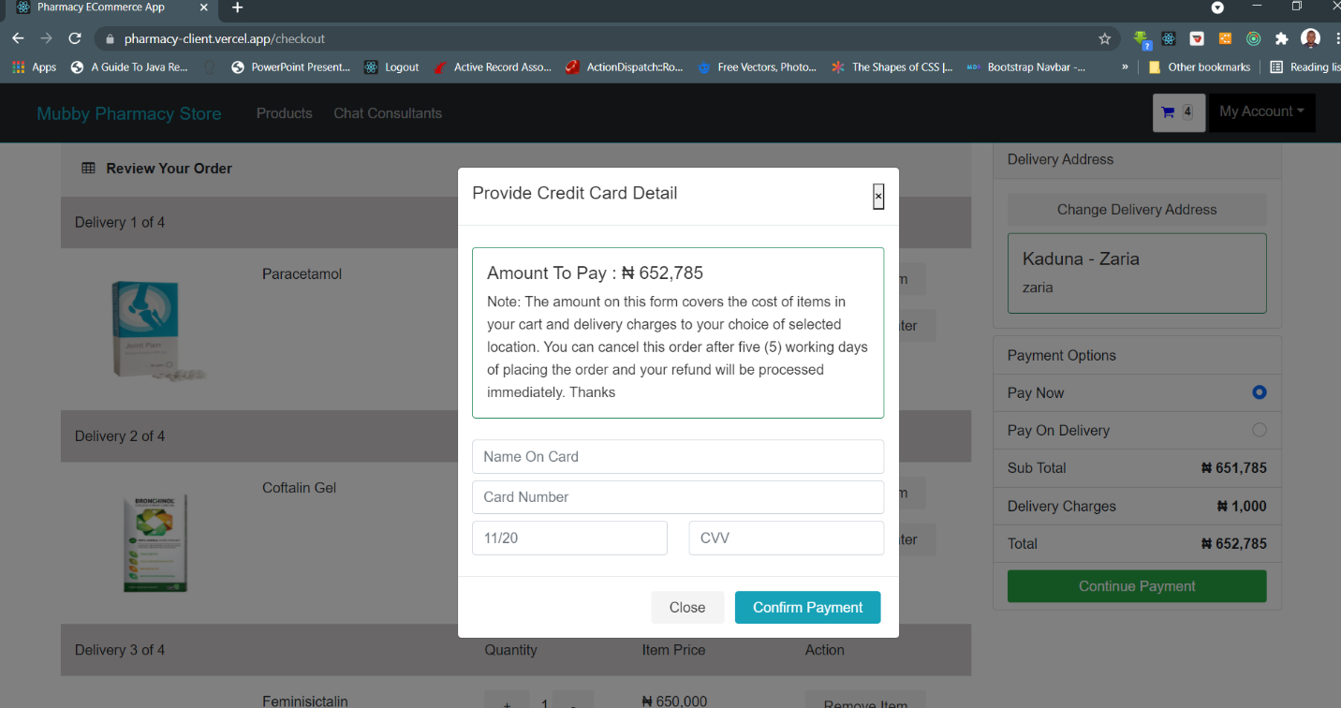

### 7.2.5 Wish List Cart

The Wish List window provide users the ability to manage items in their Wishlist. User can remove items from the Wishlist or add item on their Wishlist to cart.

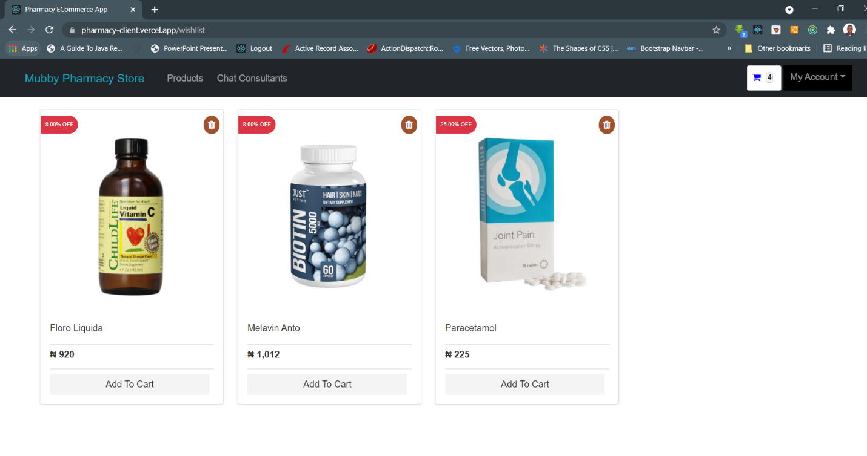

### 7.2.6 Product Preview Screen

This window provides users the complete details of a selected product and as well provide list of related products. Users can also add product to their cart or Wishlist from this screen.

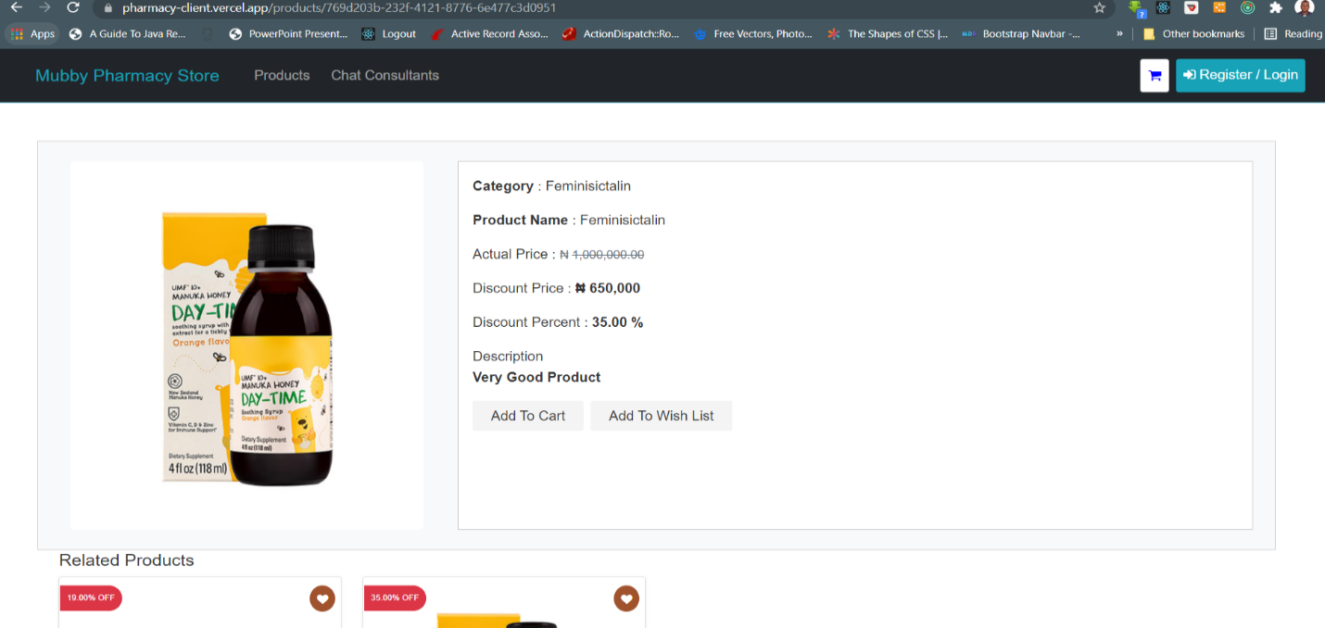

### 7.2.7 User Profile Dashboard

This window provides users with all the functionalities to manage their profile. User can update their profile information, change password and manage delivery address.

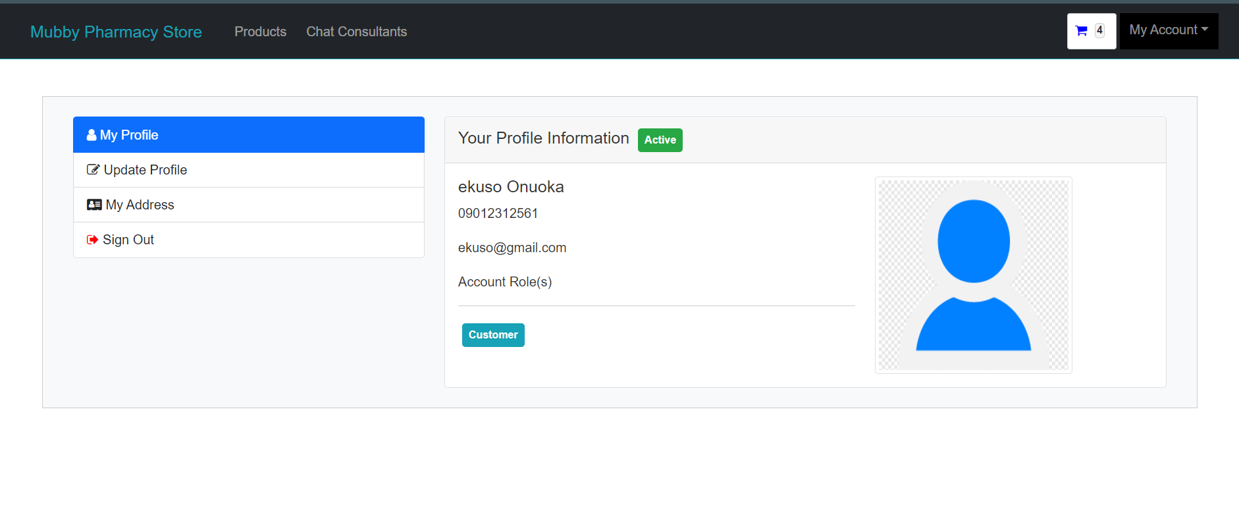

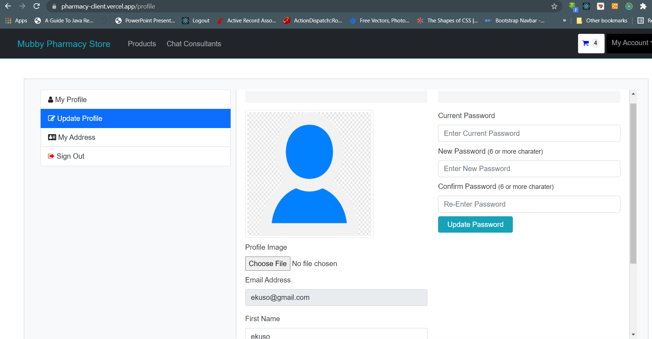

### 7.2.8 Order Management Window

This window provides users the history of all their previous orders on the platform.

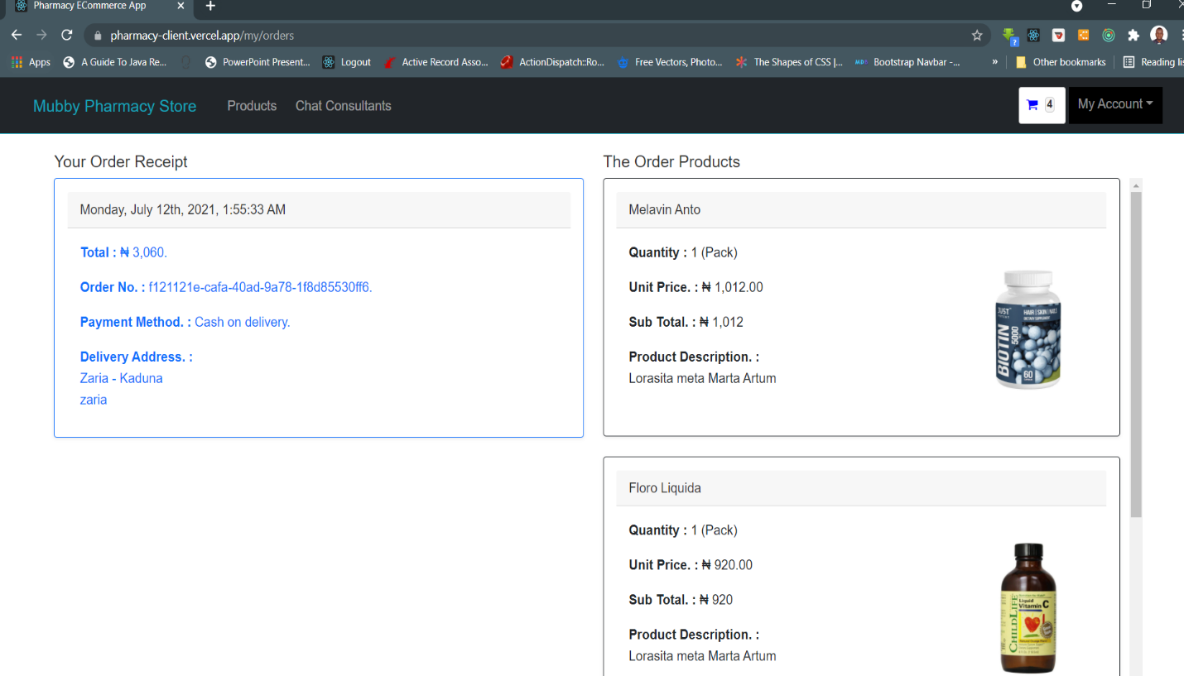

### 7.2.9 Admin Management Dashboard

This is the dashboard window for the system administrators to manage the content and resources of the system. The windows provide the administrators the ability to create / update product categories, products and change the roles of the system users.

7.2.9.1 Add / Update Category

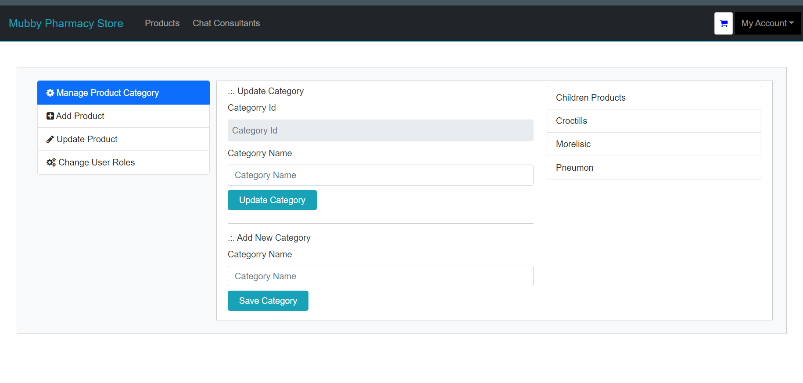

7.2.9.2 Add Product

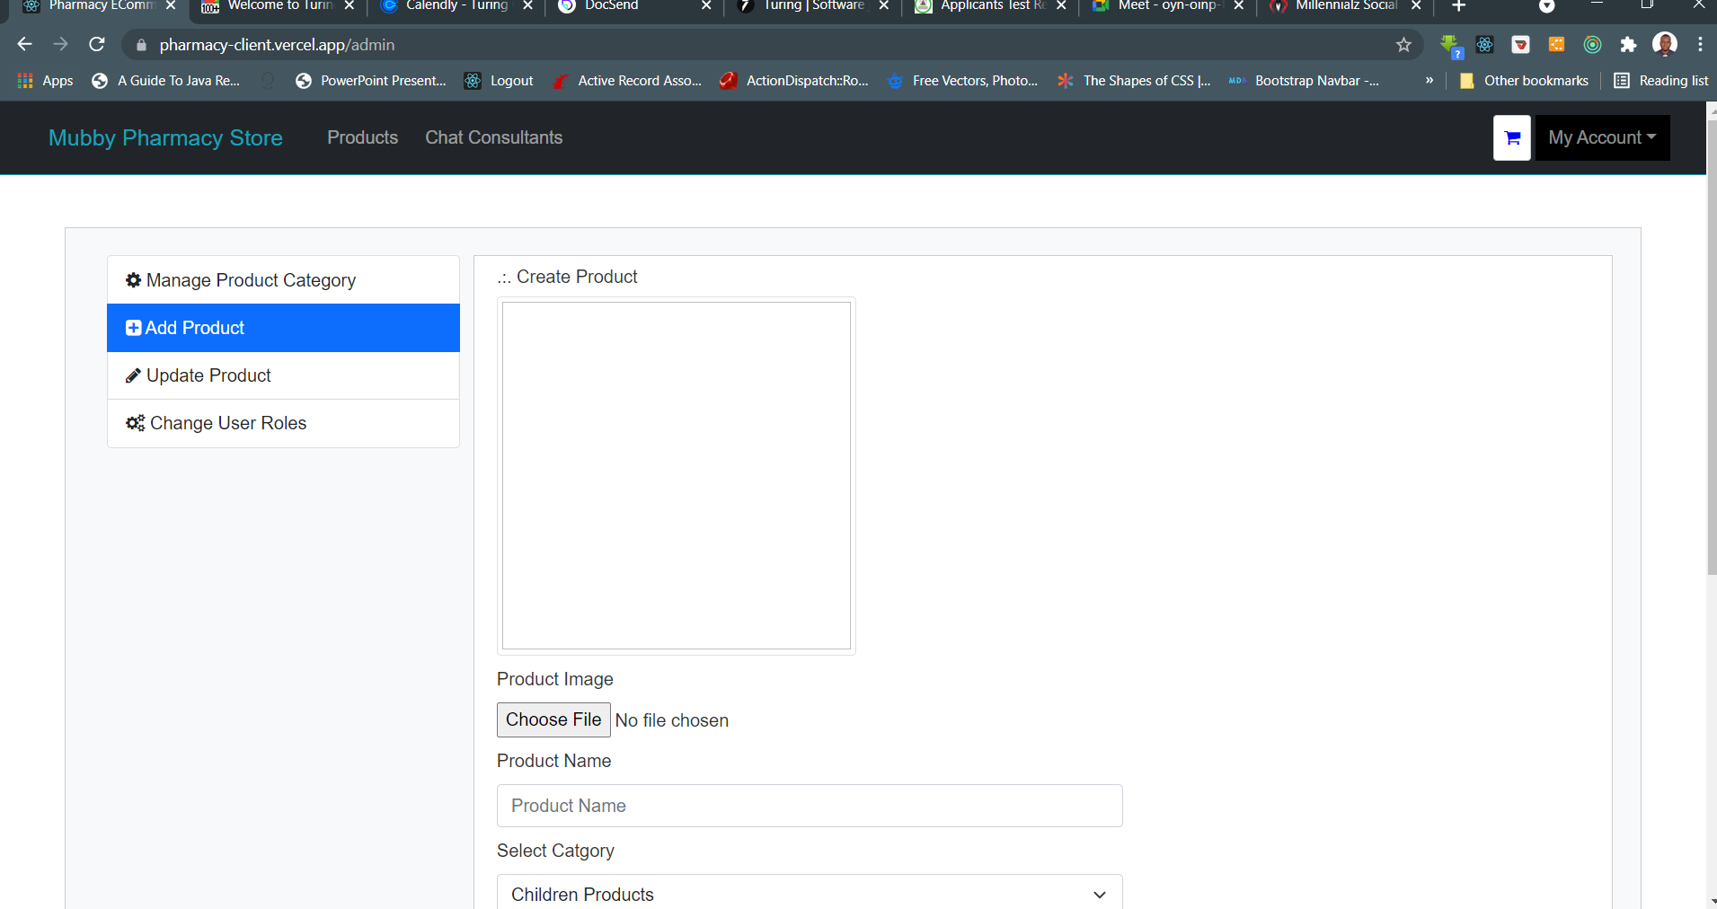

7.2.9.3 Update Products

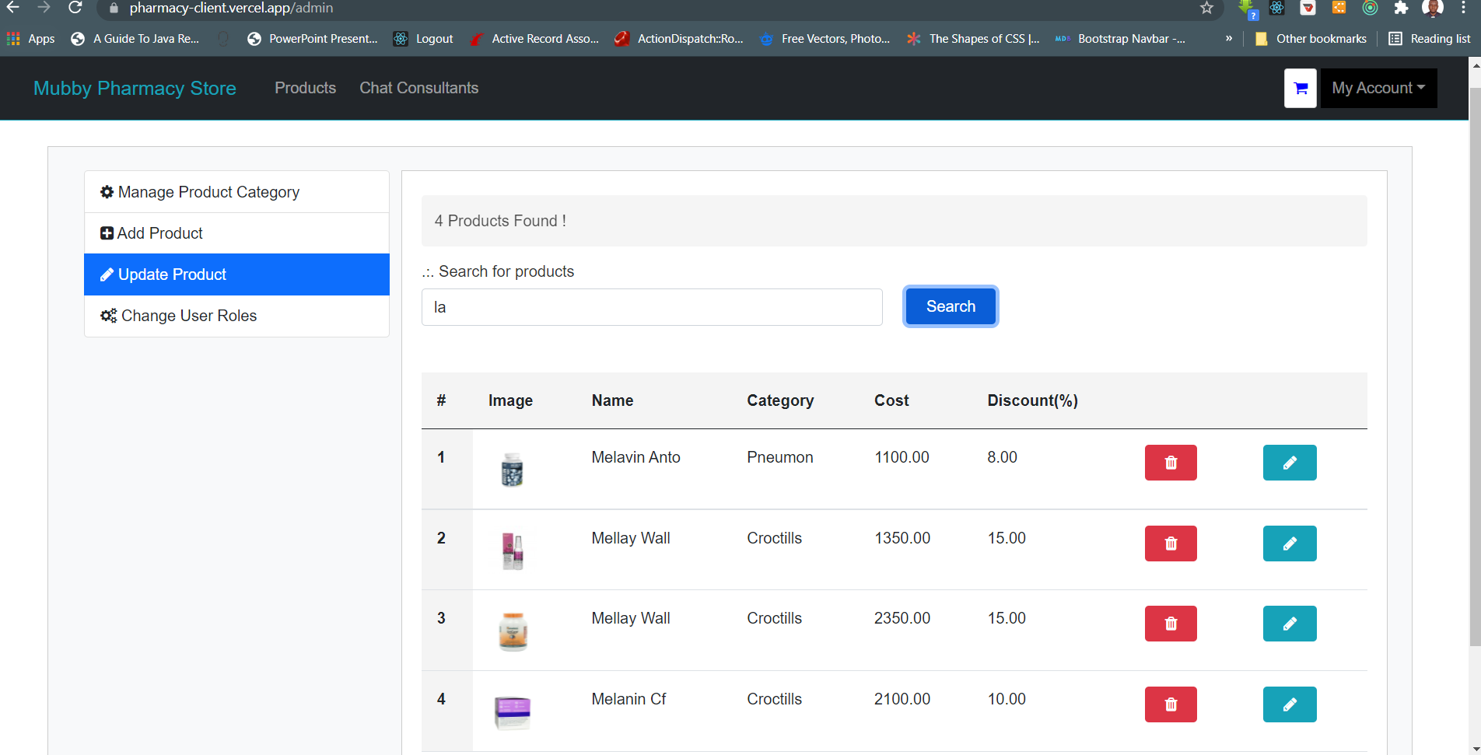

7.2.9.4 Modify User Roles

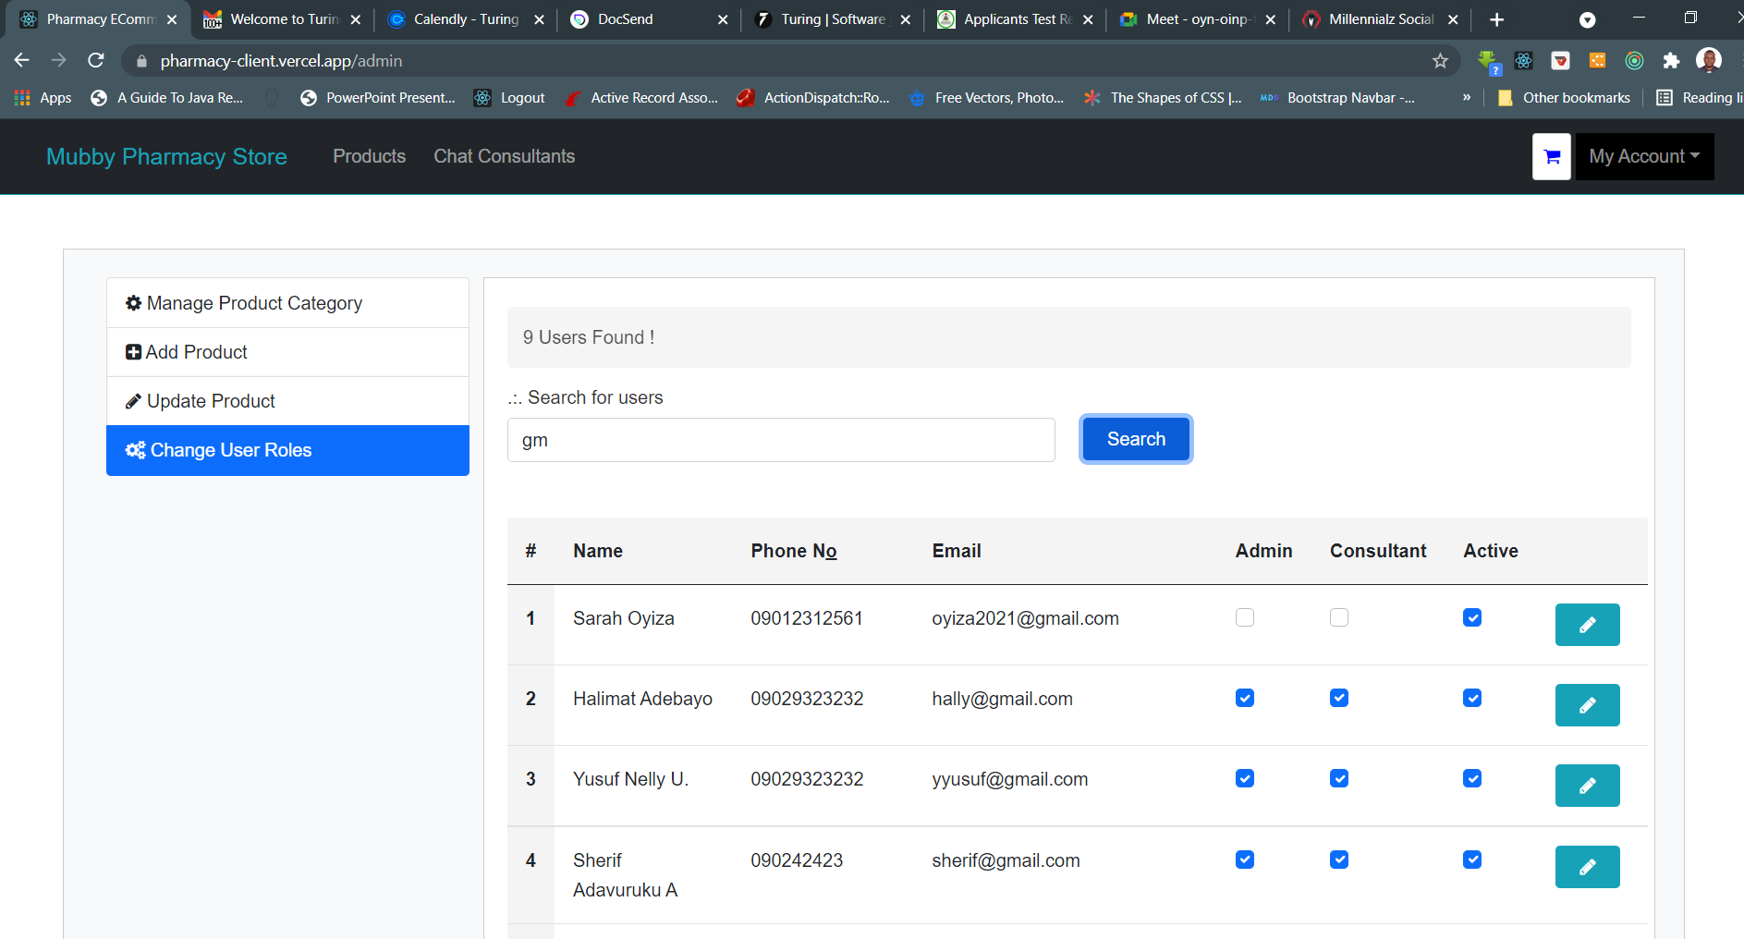

### 7.2.10 Consultation / Messenger Window

This screen provides the environment for users the ability to message and have a conversation with the registered professional consultants on the system. The users can send message to any of the consultants. Since is a real-time bidirectional messaging platform, the consultant can reply and have a real-time communication with the users.

